Packet Tracer – Configuring Static Frame Relay Maps

1. Topology

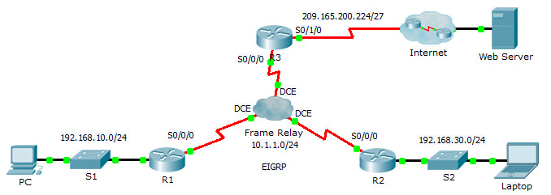

1. Addressing Table

|  |  |  |  |  |
| --- | --- | --- | --- | --- |
| Device | Interface | IP Address | Subnet Mask | Default Gateway |
| R1 | G0/0 | 192.168.10.1 | 255.255.255.0 | N/A |
| S0/0/0 | 10.1.1.1 | 255.255.255.0 | N/A |
| R2 | G0/0 | 192.168.30.1 | 255.255.255.0 | N/A |
| S0/0/0 | 10.1.1.2 | 255.255.255.0 | N/A |
| R3 | S0/0/0 | 10.1.1.3 | 255.255.255.0 | N/A |
| S0/1/0 | 209.165.200.225 | 255.255.255.224 | N/A |
| ISP | S0/0/0 | 209.165.200.226 | 255.255.255.224 | N/A |
| Web | NIC | 209.165.200.2 | 255.255.255.252 | 209.165.200.1 |
| PC | NIC | 192.168.10.10 | 255.255.255.0 | 192.168.10.1 |
| Laptop | NIC | 192.168.30.10 | 255.255.255.0 | 192.168.30.1 |

1. Objectives

Part 1: Configure Frame Relay

Part 2: Configure Static Frame Relay Maps and LMI Types

1. Scenario

In this activity, you will configure two static Frame Relay maps. Although the LMI type is autosensed on the routers, you will statically assign the type by manually configuring the LMI.

1. Configure Frame Relay
   1. Configure Frame Relay encapsulation on the S0/0/0 interface of R1.

R1(config)# **interface s0/0/0**

R1(config-if)# **encapsulation frame-relay**

* 1. Configure Frame Relay encapsulation on the S0/0/0 interfaces of R2 and R3.
  2. Test connectivity.

From the command prompt on **PC**, verify connectivity to the **Laptop**, located at 192.168.30.10, using the **ping** command.

The ping from **PC** to **Laptop** should fail because **R1** does not have a route to reach the 192.168.30.0 network. **R1** must be configured with a Frame Relay map so that it can find the next hop destination to reach that network.

1. Configure Static Frame Relay Maps and LMI Types

Each router requires two static maps to reach the other routers. The DLCIs to reach these routers are provided below.

* 1. Configure static maps on R1, R2, and R3.
     1. Configure **R1** to use static frame relay maps. Use **DLCI 102** to communicate from **R1** to **R2**. Use **DLCI 103** to communicate from **R1** to **R3**. The routers must also support EIGRP multicast on 224.0.0.10; therefore, the **broadcast** keyword is required.

R1(config)# **interface s0/0/0**

R1(config-if)# **frame-relay map ip 10.1.1.2 102 broadcast**

R1(config-if)# **frame-relay map ip 10.1.1.3 103 broadcast**

* + 1. Configure **R2** to use static Frame Relay maps. Use **DLCI 201** to communicate from **R2** to **R1**. Use **DLCI 203** to communicate from **R2** to **R3**. Use the correct IP address for each map.
    2. Configure **R3** to use static Frame Relay maps. Use **DLCI 301** to communicate from **R3** to **R1**. Use **DLCI 302** to communicate from **R3** to **R2**. Use the correct IP address for each map.
  1. Configure ANSI as the LMI type on R1, R2, and R3.

Enter the following command on the serial interface for each router:

R1(config-if)# **frame-relay lmi-type ansi**

* 1. Verify connectivity.

The **PC** and **Laptop** should now be able to ping each other and the **Web Server**.